Ghazian Progress Report

York University, Toronto, ON

Spring 2021

**The relative importance of shelter on microclimate, plants, and animals in desert communities.**

**Examination Committee:**

Dr. Christopher Lortie

Dr. Suzanne MacDonald

Dr. Laura McKinnon

Table 1. Ph.D. Research chapters and timeline.

|  |  |  |  |
| --- | --- | --- | --- |
| **Chapter** | **Title** | **Timeline** | **Theory** |
| **1** | **Finding the sweet spot in camera trapping: a review of camera trap papers to test for reported sampling effort in population estimates.** | * First draft of manuscript is attached. * Going to submit it to the journal of Methods in Ecology and Evolution as a mini-review paper. | * Sampling theory. |
| **2** | **Quantifying the extend of microclimatic amelioration of natural fabrics and estimating effects on native and exotic seedlings.** | * Trials are currently being conducted in the lab. * Preliminary data are collected. | * Microclimatic amelioration and shrub canopy mimic. |
| **3** | **The impact of artificial shelter deploys on microclimate and patterns in animal habitat usage.** | * Spring-summer 2022 field season. | * Spatial heterogeneity and climatic amelioration. |
| **4** | **Effects of shelter on understory plant germination.** | * Spring-summer 2023 field season. | * Facilitation and context-dependence. |
| **5**  **Bonus Synthesis** | **A synthesis of shelter amelioration for animals.** | * Systematically review the literature Spring-Summer 2021. * Conduct a meta-analysis. | * Mechanistic analysis of facilitation effects of shelters on animals. |

**Background**

The incidence and strength of anthropogenic disturbances are globally increasing in all systems. These changes reduce biodiversity by decreasing the amount of available terrestrial habitat for both plants and animals (Nopper et al. 2018; Irwin et al. 2010; Elmqvist 2013). If we continue with the current trends, likely, resident species can no longer behaviourally mitigate climate and land-use changes, such as urbanization and agriculture dryland systems (Germano et al. 2011). Many organisms in drylands are not only sensitive to large-scale changes but also small, fine-scale fluctuations (Shrode and Gerking 1977; Hadley 1970). Changes in the environment at fine-scales can push species beyond the point of no return and force local extirpations because of the relative climate envelopes (Ivey et al. 2020; Vickers, Manicom, and Schwarzkopf 2011) and the species’ capacity to adapt to a changing climate (Bauwens, Hertz, and Castilla 1996; Visser 2008) or to migrate (Lennox et al. 2016; Seebacher and Post 2015). Long-term climate patterns can mediate reproduction and distribution (Bellard et al. 2012; Walther 2010) but fine-scale, microclimatic data can impact the immediate day-to-day survival. Hence, the scale at which climate is measured is important for different species. Effective conservation and management strategies must integrate microclimatic data with coarse-scale measurements since only considering macro-level data can be detrimental to the survival of many animals.

The presence of vegetation is key for ecosystem resilience because vegetation provides habitat for other trophic levels. Resilience is defined as the ability of a community to recover its composition and function and to continue to persist after changes introduced by disturbance (Torok et al. 2020). Shrubs and likely many perennials with a canopy, can function as structural agents of facilitation and provide benefit to other taxa through the canopies by ameliorating the microclimate (Filazzola et al. 2017). Canopy microclimates are generally cooler, more humid, and experience less direct solar radiation (Filazzola et al. 2017; Holzapfel and Mahall 1999). Vegetation can also provide cooler temperatures during the hottest times of the day and thus provides refuges for species and is an important driver of habitat selection for many vertebrate species (Kline et al. 2019). Thus, shrubs can help plants and animals address climatic stressors at fines-scales, which matter to them. *Ephedra Californica* (Mormon Tea) is a common foundation shrub and native to the Southwestern regions of California (Sawyer, Keeler-Wolf, and Evens 2009). *Ephedra* is a great example of abiotic amelioration through the canopy as it facilitates plant species (Lortie et al. 2018) and animals (Ivey et al. 2020).

Shelters have relatively extensive use and are important for ecological interactions in deserts as well as being a physical presence or natural and artificial form of architecture. Shrubs, solar farm deploys, and artificial shelters can increase spatial heterogeneity of the landscape for plants or animals: for example, some birds use shelters for perching (Athiê and Dias 2016), whilst some snakes use them to thermoregulate (Lelièvre et al. 2010). Spatial heterogeneity concerns the physical location of organisms or entities (such as plants in a community) through space and the variation in the density of such points (Dutilleul 1993). Shelters, whether natural or artificial, can also facilitate other vegetation growing in their understory by increasing plant production and Leaf Area Index (LAI) of understory plants, mainly due to their windbreak abilities (Sudmeyer et al. 2002). We recently completed a pilot study using artificial shelters and found that they can provide a stable temperature regime and less direct solar radiation (Ghazian, Zuliani, and Lortie 2020). These shelters can be used as a restorative solution - particularly if the canopy is made from more eco-friendly materials. However, we have not tested its ecological impacts on other plant and animal species. The general and overarching hypothesis of the thesis is thus that eco-friendly, artificial shelters can ameliorate the canopy microclimate and create spatial heterogeneity in the landscape, which is essential for the persistence of plants and animals. To test this thesis-level objective, we first determine the relative sampling efforts needed to estimate biodiversity in animals through a meta-analysis. Secondly, to ensure that artificial shelters are eco-friendly, we conduct in-lab trials to test a variety of fabrics and ultimately test the winning fabric in the field. Then - main chapter – In the field, we test the microclimatic and spatial heterogeneity benefits of deploying shelters at two sites and measure both fine-scale climate, vegetation responses, and animal use through camera trapping. Provided that there is time and depending on fieldwork, we will also do broad scientific synthesis to explore the generality of the microclimatic amelioration of shelters for animals in a meta-analysis. This will frame the experimental findings from this region in global research trends.

**Main Thesis Objectives**

1. Identify key sampling designs with camera traps.
2. Record microclimatic impacts of eco-friendly materials and their influence on plant species under controlled conditions.
3. Demonstrate ecological effects of shelters in the field.
4. Compile frequency and ecological strength of microclimate facilitation reported in the literature.

**Chapter 1. Finding the sweet spot in camera trapping: a review of camera trap papers to test for reported sampling effort in population estimates. (Draft Attached)**

**Purpose:** To test for the relationship between trapping effort and vertebrate diversity.

**Hypothesis:** Increasing the number of available camera traps and trapping days will increase detection probabilities and hence species diversity.

**Findings:** Increasing the number of cameras had a net positive effect specifically in grasslands and deserts. The greater number of camera traps returned higher capture rates. Furthermore, Increasing the length of the study did no increase capture rate or diversity.

**Chapter 2: Quantifying the extend of microclimatic amelioration of natural fabrics and estimating effects on native and exotic seedlings.**

**Purpose:** To quantify the extent to which different natural fabrics facilitate the understory annual plant growth in comparison to the open gap.

**Questions:** How do different natural fabrics such as burlap, cotton, and nursery seedling cloth affect microclimatic parameters such as RH, temperature, and light? How do different fabrics affect understory annual growth? Are annuals and foundation plants facilitated to the same extend?

**Hypothesis:** Fabrics will lower the amplitude of variation in microclimatic parameters such as temperature, RH, and radiation relative to the open.Germination rates of annual plants and foundation species do not differ between different fabrics and it will all be higher than the open gap.

**Predictions:**

* Different fabrics influence light permeability to different extents. Too much light exposure can decrease germination in some desert species. Hence, fabrics create a barrier from direct solar radiation and create shade for the young seedlings, so germination can occur more effectively compared to the open.
* Artificial barrier/canopy can increase humidity and create a windbreak environment, which in turn aids in understory plant growth.

**Methods**

Trials are currently being conducted in controlled lab conditions. We selected three environmentally-friendly fabrics: burlap, 100% cotton canvas, and seedling nursery fabric. Natural burlap is made from hemp or jute fibers that are generally treated to resist decay (Kuhns 1997). Cotton canvas has a structure made of cellulose and is great for short time use, however over time when subjected to tension, humidity alongside temperature fluctuations, as well as UV irradiation over time, can degrade the fabric (Nechyporchuk et al. 2017). Biodegradable nursery fabrics are superior to plastic ones and are used to increase the rates of seedling establishment as they hold more moisture (Wightman et al. 2001). In this experiment, fabrics were set up at an angle to the ground to create shade. Approximately 1490 seeds of the annual species *Phacelia tanacetifolia* (fiddleneck) were planted in seedling propagation trays with the dimensions 53.34 x 27.94 x 6 cm. This resulted in a density of 1 seed/cm2. Seeds of *Cylindropuntia acanthocarpa* (buckhorn cholla) were planted in a tray with the same dimension. Tray soil mix was made from ~50% sand and 50% succulent/cacti soil mix. Trays were watered weekly. One tray of each species was placed under the fabric and one was placed in the open for a total of 3 fabric-open replicates (Figure 1). Data loggers were attached to pegs using zip ties and placed in cups filled with sand under each fabric and in the open measuring RH, light intensity, and temperature at 1-hour intervals. LED lamps provided UV for a total of 12hours/day (suggested in the manual for dryland species). 60-watt heat lamps were used to create artificial heat and remained lit for the entire duration of the study. Fabrics are tested for one month. Logger data is exported as a CSV file. Germination rates are recorded as the percentage of the total percent cover.

**Proposed Stastical Analyses**

Generalized Linear Mixed Models (GLMM) will be used to model temperature, RH, solar radiation relative to germination rates with fabric as a co-variate. A Principle Coordinate Analaysis (PCoA) may be used to visualize multiple independent variables to examine correlations.

**Preliminary Results**

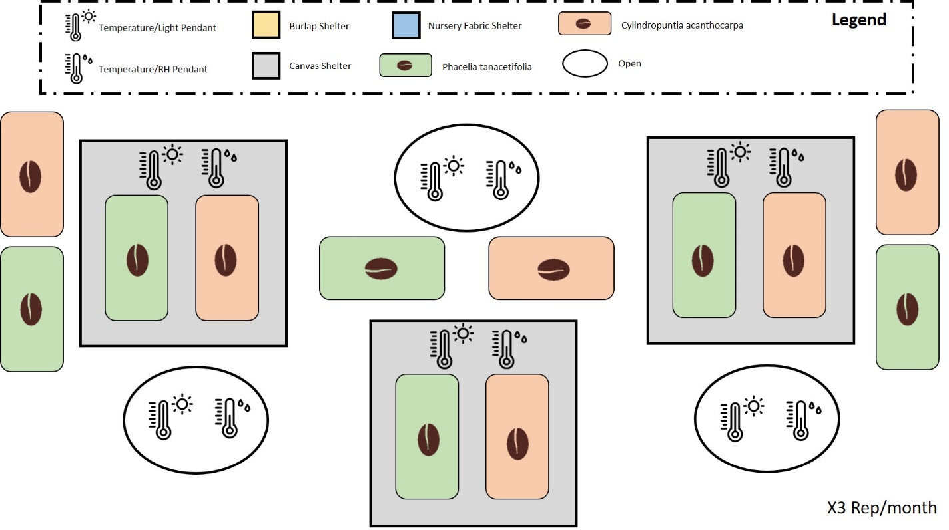Germination only occurred for *Phacelia* under the canvas fabric and not in the open or under the burlap. Logged temperatures were very similar between the two different brand loggers. Humidity was recorded at higher percentages under burlap followed by canvas. Light intensity recorded under the burlap and canvas were very similar, with canvas having slightly lower intensities.

**Figure 1. Sketch of the experimental setup for one of the fabrics. All other fabrics were tested the same way.**

**Chapter 3: The impact of artificial shelter deploys on microclimate and patterns in animal habitat usage.**

**Purpose:** To examine wildlife interactions with artificial shelters and to investigate how artificial shelters impact the soil microbial community.

**Questions:** How do UV permeable artificial shelters modify the soil microbial community richness and abundance? How often do vertebrates interact with artificial shelters? Which species interact with shelters the most often? What are they doing when interacting with shelters? Do arthropods interact with shelters? If yes, which species do most often? Does the richness and abundance of microbes differ between shelters, shrubs, and the open gap? Is the frequency and direction of vertebrate and arthropod interaction with shelters different from shrubs and the open?

**Hypothesis:** Animals will associate more with shelter microsites and shrubs than the open as canopied microsites ameliorate the microclimatic environment of the understory.

**Predictions:**

* Artificial shelters increase RH, soil moisture, and reduce microclimatic extremes.
* Soil microbial community composition under established shrubs and artificial shelters will be similar and both differ from non-canopied microsites.
* Vertebrates will positively associate with shelters and shrubs as temperature, drought, and duration of intense solar radiation increases to take refuge and to thermoregulate.

**Methods**

**Vertebrates:** The study will take place at two sites: Sheephole Valley Wilderness in the Mojave Desert (34.227, -115.553) and Northern Cuyama (34.929, -119.597). Sheephole is located at the southern point of California and Cuyama is situated further north; thus, this would allow us to test the aridity gradient. UV permeable shade cloth shelters will be built using Ghazian et al. (2020) protocol, with a modified eco-friendly design. The study will take place near medium shrub-cover areas from mid-May to mid-June to allow for seasonal variabilities. There will be a total of 12 shelters made from the winning fabric determined in the laboratory experiment (i.e. canvas, nursery seedling cloth, or burlap). We will select microsite triplets which will include a shelter, a shrub, and the equivalent open. Cameras will be mounted on pegs and set up facing the microsite at a 2-meter distance. All microsites will be georeferenced. There will be a 1-minute gap between when cameras are triggered until when they’re re-triggered to avoid repetitive images of the same individual. All images will be downloaded from SD cards and saved as Joint Photographic Expert Group (JPEG) files and data such as the presence and absence of animals will be recorded and compared across microsite. RH and temperature loggers will also be placed at microsite triplets and record data as described above. The most common species to be observed are deseret cottontail (*Sylvilagus audubonii*), kit fox (*Vulpes macrotis*), and black-tailed jackrabbit (*Lepus californicus*), for a total of 81 possible species.

**Arthropods:** Yellow-coloured pan-traps (As *E. califronica* flowers are yellow-orange) will be placed at microsite triplets and will contain soapy-water to trap insects. Insects will be collected every 3 days and will be preserved in ethanol and shipped back to Canada for expert identification.

**Microbial Community**: Soil core samples will be taken from all georeferenced microsites once at the beginning of the study and once following the completion of the study. Samples will be sent to an expert lab group at UC Davis, California for composition and abundance analysis.

**Proposed Analyses:**

Point biserial correlation will be used to assess the relationship between the animal presence (binary variable) and climatic variables. GLMM will be used to model climatic parameters, richness, and diversity estimates.

**Chapter 4: Effects of shelter on understory plant germination.**

**Purpose:** To quantify the extent to which shelters facilitate the understory annual community in comparison to natural *Ephedera califronica* shrubs and the open gap.

**Questions:** How do UV permeable artificial shelters modify microclimatic parameters such as RH? How does shape and UV permeability affect understory annual growth? Are all annuals facilitated to the same extend? How does growth compare to annuals planted underneath natural shrub canopies and in the open gap?

**Hypothesis:** Percent cover of annual plants does not differ between shrubs and artificial shelters, and both will be significantly higher than the open.

**Predictions:**

* Artificial shelters increase humidity and create a windbreak environment, which in turn aids in understory plant growth.
* Shelter and shrubs shade seedling from direct sunlight, allowing for more effective germination.
* The microclimatic conditions create via shelters will be similar to those of shrubs; hence, understory plant growth (percent cover) will also be similar in both microsites.

**Methodology:** The study will take place at two sites: Sheephole Valley Wilderness in the Mojave Desert (34.227, -115.553) and Northern Cuyama (34.929, -119.597). The shelters will be built using Ghazian et al. (2020) protocol, with a modified eco-friendly design. Seeds of two annual species (species to be selected) will be sown underneath shelters at the end of winter/beginning of spring growth period (~February-March). There will be a total of 12 shelters. All seedlings will be watered regularly. All plants present underneath/around the shrub and artificial canopy will be removed before the experiment and the soils will be sieved. Annual seeds will also be planted in shrub-open pairs. All shelters and shrub-open pairs will be geo-references. RH and temperature data loggers will be attached to pegs via zip ties and placed ~10 cm above ground under each shelter and shrub-open pair and set to log in 1-hour intervals. Shrub dimensions will be measured in X, Y, and Z planes to allow for canopy volume calculations later on. Shelter and loggers will be left out in the field under the end of the growing period (~end of April/mid-March) at which point microsites will be visited and understory plant growth will be measured as the percent cover of each species relative to the total cover.

**Chapter 5 (Bonus): A synthesis of shelter amelioration for animals.**

**Purpose:** To systematically review the relevant literature on artificial shelters to test the frequency and the extent of the use of shelter amelioration for resident species.

**Questions:** How are shelters used ecologically? How often are artificial shelters used in the literature, specifically for animal habitat amelioration? What species are most commonly examined? How were the shelters used (i.e. thermoregulation, shade, perching, etc.)? What parameters are most often reported in shelter studies? Are effect sizes measured and reported?

**Methods**

Figure 2 represents the workflow for extracting relevant data. Literature will be obtained through keyword searches in ISI Web of Science (WoS) using a mixture of the keywords artificial shelter* AND animal*. Google Scholar and book chapters will also be reviewed to validate the publication coverage of WoS. The list of papers will be exported as a CSV file. Abstracts will be reviewed and all opinion, review, and idea papers will be removed so that the focus remains on empirical studies. Data such as the location of the study reported taxa and species, type of shelter, as well as function will be recorded. All taxa will be considered. Meta-statistical analyses will be conducted. This includes calculating effect sizes were using the function *escalc* from the *metafor* package (Viechtbauer 2010) in R and applying random-effects models (*rma)* to analyze estimate values, stand error, and heterogeneity.

Papers obtained through database searching (Web of Science) Keywords:

Artificial shelter* animal*

(n= 121)

(n= 515)

(n = 1090)

## Identification

Papers obtained from other sources, such as book chapter bibliographies

(n= )

## Eligibility

Records after duplicates removed   
(n = )

Records excluded for: relevance, review, opinion or idea paper, qualitative, not written in English.

Records screened by abstract (n = )

## Screening

Full-text articles excluded

Full-text articles assessed for eligibility (n = )

(n = )

Include in synthesis

(n = )

## Included

Extracted data:

Location (latitude, longitude), year of study, type of shelter, function/purpose of shelter, taxa of study, and study species.

**Figure 1. PRISMA adapted from Moher et al. (2009).**

**Work Cited**

Athiê, S., and M. M. Dias. 2016. “Use of Perches and Seed Dispersal by Birds in an Abandoned Pasture in the Porto Ferreira State Park, Southeastern Brazil.” *Brazilian Journal of Biology* 76 (1): 80–92. https://doi.org/10.1590/1519-6984.13114.

Bauwens, Dirk, Paul E. Hertz, and Aurora M. Castilla. 1996. “Thermoregulation in a Lacertid Lizard: The Relative Contributions of Distinct Behavioral Mechanisms.” *Ecology* 77 (6): 1818–30. https://doi.org/10.2307/2265786.

Bellard, Céline, Cleo Bertelsmeier, Paul Leadley, Wilfried Thuiller, and Franck Courchamp. 2012. “Impacts of Climate Change on the Future of Biodiversity: Biodiversity and Climate Change.” *Ecology Letters* 15 (4): 365–77. https://doi.org/10.1111/j.1461-0248.2011.01736.x.

Dutilleul, Pierre. 1993. “Spatial Heterogeneity and the Design of Ecological Field Experiments.” 74 (6). https://doi.org/10.2307/1939923.

Ghazian, Nargol, Mario Zuliani, and Christopher Lortie. 2020. “Micro-Climatic Amelioration in a California Desert: Artificial Shelter Versus Shrub Canopy.” *Journal of Ecological Engineering* 21 (8): 216–28. https://doi.org/10.12911/22998993/126875.

Kuhns, Michael R. 1997. “Penetration of Treated an Untreated Burlap by Roots of Balled-and-Burlapped Norwar Maples.” 23 (1).

Lelièvre, Hervé, Gabriel Blouin-Demers, Xavier Bonnet, and Olivier Lourdais. 2010. “Thermal Benefits of Artificial Shelters in Snakes: A Radiotelemetric Study of Two Sympatric Colubrids.” *Journal of Thermal Biology* 35 (7): 324–31. https://doi.org/10.1016/j.jtherbio.2010.06.011.

Lennox, Robert J., Jacqueline M. Chapman, Christopher M. Souliere, Christian Tudorache, Martin Wikelski, Julian D. Metcalfe, and Steven J. Cooke. 2016. “Conservation Physiology of Animal Migration.” *Conservation Physiology* 4 (1): cov072. https://doi.org/10.1093/conphys/cov072.

Nechyporchuk, Oleksandr, Krzysztof Kolman, Marta Oriola, Michael Persson, Krister Holmberg, and Romain Bordes. 2017. “Accelerated Ageing of Cotton Canvas as a Model for Further Consolidation Practices.” *Journal of Cultural Heritage* 28 (November): 183–87. https://doi.org/10.1016/j.culher.2017.05.010.

Seebacher, Frank, and Eric Post. 2015. “Climate Change Impacts on Animal Migration.” *Climate Change Responses* 2 (1): 5. https://doi.org/10.1186/s40665-015-0013-9.

Sudmeyer, R. A., M. C. Crawford, H. Meinke, P. L. Poulton, and M. J. Robertson. 2002. “Effect of Artificial Wind Shelters on the Growth and Yield of Rainfed Crops.” *Australian Journal of Experimental Agriculture* 42 (6): 841. https://doi.org/10.1071/EA02018.

Torok, Peter, James M. Bullock, Borja Jimenez-Alfaro, and Judit Sonkoly. 2020. “The Importance of Dispersal and Species Establishment in Vegetation Dynamics and Resilience” 31 (6). https://doi.org/10.1111/jvs.12958.

Viechtbauer, Wolfgang. 2010. “Conducting Meta-Analyses in *R* with the Metafor Package.” *Journal of Statistical Software* 36 (3). https://doi.org/10.18637/jss.v036.i03.

Visser, Marcel E. 2008. “Keeping up with a Warming World; Assessing the Rate of Adaptation to Climate Change.” *Proceedings of the Royal Society B: Biological Sciences* 275 (1635): 649–59. https://doi.org/10.1098/rspb.2007.0997.

Walther, Gian-Reto. 2010. “Community and Ecosystem Responses to Recent Climate Change.” *Philosophical Transactions of the Royal Society B: Biological Sciences* 365 (1549): 2019–24. https://doi.org/10.1098/rstb.2010.0021.

Wightman, Kevyn Elizabeth, Ted Shear, Barry Goldfarb, and Jeremy Haggar. 2001. “Nursery and Field Establishment Techniques to Improve Seedling Growth of Three Costa Rican Hardwoods.” *New Forests* 22 (1/2): 75–96. https://doi.org/10.1023/A:1012020023446.

**Finding the sweet spot in camera trapping: a review of camera trap papers to test for reported sampling effort in population estimates.**

Nargol Ghazian1* and Christopher J. Lortie1

1Department of Biological Science, York University, 4700 Keele St, Toronto, ON M3J 1P3, Canada

*Corresponding Author: Department of Biological Science, York University, 4700 Keele St, Toronto, ON, M3J 1P3, Canada. Email: [nargolg1@my.yorku.ca](mailto:nargolg1@my.yorku.ca)

**Abstract**

1. Camera traps have become one of the most popular tools in the area of wildlife research and their use is prevalent in many studies examining activity patterns, animal behaviour, as well estimation of population parameters such as occupancy, abundance, and diversity. Thus, an overview of the literature examining the threshold of sampling in different ecosystems is valuable.
2. A synthesis of camera trap papers to test for reported sampling effort was carried where we reviewed over 252 full-text articles. Using exclusion criteria, we included 119 studies in our analysis and extracted data pertaining to sampling effort, including the number of camera trap days and photographs, richness, and the system of study. A meta-analysis was carried out to test for the relationship between trapping effort and vertebrate diversity.
3. Our results illustrate that the net positive effect for increasing the number of cameras is positive. This means a greater number of camera traps returns higher capture rates, specifically in deserts and grasslands, and higher diversity in the majority of systems of study. Increasing the duration of trapping did not necessarily increase capture rate or diversity.
4. Camera trap will continue to grow in popularity as a tool in the years to come; hence, it is important to consider all aspects of experimental design to maximize the probability of collecting biodiversity data that is as true of the representation of the natural community as photographs can be.

**Keywords**

Camera traps, diversity, population estimates, richness, sampling effort

**Introduction**

Camera traps provide a means to survey wildlife and its interactions with the surrounding environment with relatively little human interference. These survey devices normally record animal presence via a triggered passive, infrared motion sensor (Marcus Rowcliffe et al. 2011). They are one of the most popular survey tools in current wildlife research, particularly in the domain of terrestrial vertebrate biology (P. Meek et al. 2014), used to record activity patterns and determine parameters such as occupancy, abundance, and diversity (Karanth et al. 2004; Kelly et al. 2008). Besides their use in wildlife research, camera traps have been used in studies that focus on nest ecology, detection of rare species, estimation of population size and species richness, behavioural studies, habitat use, and occupation of human-built structures (Cutler and Swann 1999; O’Connell et al. 2011 ). Thus, camera traps are a versatile method for collecting data on the functioning of many systems that can be used for a variety of management and conservation practices. Knowing their popularity in abundance and diversity research, herein we examine the sampling effort of this tool to predict animal diversity for a system.

Various crucial aspects can influence the number of species detected by camera traps, as well as the trapping rate (ratio of photographs to camera trapping time (Rovero and Marshall 2009)). These include trigger speed, detection zone, recovery time, night detection, and battery consumption that can impact the collected data (Hughson and Darby 2010). Limitations of this method can also arise from camera models, placement and orientation, temperature differentials, and species behavioural responses (P. D. Meek, Ballard, and Fleming 2015). The factors can be summarized as trapping effort and trapping design and can affect estimates of abundance and diversity (Yasuda 2004; Wegge, Pokheral, and Jnawali 2004).

Trapping rate is a useful index for abundance and diversity estimates (Rovero and Marshall 2009; J. Marcus Rowcliffe et al. 2008; Silveira, Jácomo, and Diniz-Filho 2003). Minimum trapping effort (MTE) is another important factor for population estimates. MTE refers to the number of camera trap days required to record species of interest in an area (Si, Kays, and Ding 2014) and varies extensively across studies. The number of camera traps used in a study is directly related to both trapping design and effort because a small number of cameras can result in low detection probabilities and affect the strength of population estimates (Foster and Harmsen 2012). The interplay amongst these elements provides us with an excellent opportunity to explore the relationship between trapping time, number of cameras, and richness estimates across the literature.

In the present study, we conducted a systematic review of camera trap literature to test for sampling effort as a predictor of animal diversity. We tested the threshold for sampling and provided an overview of the relationship between trapping rate and richness, and tested if the ecosystem affects this relationship. Given that camera traps are increasingly being used in wildlife estimations, our study can provide some insight into the ‘sweet spot’ in sampling in different systems. This is valuable considering the connectedness of this tool for data acquisition and the implementation of conservation and management practices.

**Methods**

***Systematic review***

We conducted a systematic review using the terms Camera Trap* AND Richness*, Camera* Trap* AND Diversity*, and Camera Trap* AND Rarefaction* Curve* in ISI Web of Science (WoS). This search was done in January 2019. Search results were exported as a CSV file and are available publicly alongside the dataset (Figshare citation). Additionally, we conducted supplemental searches in book chapters and Google Scholar to validate the publication coverage of WoS. Searches resulted in a total of 397 publications once duplicates were removed. PRISMA diagram from Moher et al. (2009) demonstrates selection and review procedure (SA, A). We screened the abstracts and excluded papers based on relevance, whether they were a review, opinion, or idea paper, and if they focused on one species and were not quantitative. Moreover, only English language research papers were further examined. Full-text articles if they included: 1) a measure of richness or diversity; 2) the number of records; 3) duration of camera trapping (days). Additional variables such as the number of cameras and sites, as well the system were also recorded. The system of study was simplified into ecosystem, including coniferous, deciduous, desert, grassland, tropical, and mixed. In total, we screened 252 full-text articles.

***Statistical analyses***

All meta-statistical analyses were performed in R version 4.0.4 (R Development Core Team 2021). Codes are published openly on Zenodo (Citation). Species richness and the number of captures were independent event count variables and treated as raw incidence rates using the number of cameras in effect size calculations (PT Higgins, Li, and Deeks 2021). Effects sizes were calculated using the function *escalc* from the *metafor* package (Viechtbauer 2010). Random-effects models (*rma)* were applied to analyze estimate values and stand error for the number of cameras (sampling effort) and the number of captures and species diversity. Heterogeneity in models was examined to ensure that variance does not rise from grouping similar measures in random-effect models (Langan et al. 2019). Forest plots were constructed using the function *ggplot* from the package *ggplot2* (Wickham 2009) where the dashed vertical line represents no effect and studies that do not cross this line significantly differ from the null effect (Verhagen and Ferreira 2014).

**Results**

A total of 119 articles were included in this study. Most studies were either conducted in tropical or deciduous forests. Residual funnel plots were asymmetrically-skewed, indicating systematic heterogeneity (SA, B and C). Mixed-effect models were used to model the number of cameras as sampling effort by the number of captures and the estimate was significantly positive (132.9475 ± 35.6037, p<0.0001, Figure 1). There was significant heterogeneity between groups (Q = 299612.31, p<0.0001). We tested the same model with the variable ‘ecosystem’ and found it to be a significant moderator (F = 5.6266, p-Value = 0.0002). The relationship remained positive in all systems but was only significant in deserts and grasslands (Table 1 and SA, D). Significant heterogeneity between groups was observed (Q = 237835.99, p = 0.0002). Additionally, the number of camera trap days was not a significant moderator in this model.

Subsequently, we modeled the effect between the number of cameras and richness found a smaller effect size than the above model, though still significantly positive (0.7878 ± 0.1064, p<0.0001, Figure 1). Heterogeneity between groups was significant (Q = 94675.90, p<0.0001). Ecosystem was a significant moderator in this model (F = 16.15, p<0.0001) and animal richness significantly increased with the number of cameras in all ecosystems except coniferous forest (Table 2 and SA, E). The number of days was also not significant as a moderator in this model. Both the capture rate and richness rate were different from the null effect in all systems (SA, Figures 3 and 4, forest plots).

**Discussion**

Our results demonstrate the utility of camera traps as a tool in population estimate studies. In the last 20 years, camera traps have not only become more readily available as a tool but have also become more affordable (J. M. Rowcliffe and Carbone 2008), which is good news for conservation, ecology, wildlife, and species inventory studies. Their popularity in richness estimate studies (Tobler et al. 2008b; 2008a) provides us with the opportunity to explore aspects related to experimental design, intending to develop future frameworks that aid in the optimization of camera trapping procedures. The idea that trapping may be influenced by the number of cameras was supported here with increased number of cameras returning significantly higher capture rates specifically in grasslands and deserts. We demonstrated that increased number of cameras also resulted in higher diversity in almost all ecosystems, except for coniferous forest. Additionally, it did not come as a surprise that increasing the number of trapping days past a certain point did not increase the capacity of the number of cameras to detect more animal species. This evidence suggest that the chosen system of study may be key to enhancing trapping effort and offers a great deal of promise for the utilities of camera traps in arid scrubland and grassland.

The number of cameras used in the study affects the trapping effort. We found that the net effect of increasing the number of cameras was positive. As well, the increase in the number of cameras resulted in the highest captures of animal diversity. According to Ferreras et al. (2017) success in detecting all the species in the system depends on many factors, including the number of cameras. They too suggest that it is more efficient to deploy more camera traps for a shorter duration rather than to deploy fewer camera traps for a longer one, for any given number of camera traps days. There is an enormous expansion in the number of sites that camera traps are being used and most literature acknowledges the fact that one cannot discuss the notion of the number of cameras without talking about how far apart cameras were placed and how extensively the site was studied. Trap placement designs are important and the use of systematic trap placement design or a design suited to the habitat may be appropriate if the primary goal of the survey is richness estimation (O’Brien 2008). To limit the chance of missing species, camera traps should not be too close together and maximize the total area covered (O’Connell, Nichols, and Karanth 2011). The interrelatedness of camera trap placement and the number of cameras is not an idea that we explored *per se*, though is integral in maximizing the potential of camera traps for wildlife monitoring.

The duration of camera trapping has to be adequate-enough so that rare species can be detected (O’Brien, Kinnaird, and Wibisono 2011). Previously, we discussed the idea of MTE and its variation across the literature. Differences in the number of camera trap days across studies are related to animal richness at the site. MTE can be affected by habitat, local characteristics, target community, and sampling strategy, including camera spacing, presence or absence of bait, and camera models (Kelly 2008; Rovero and Marshall 2009; Wegge, Pokheral, and Jnawali 2004). Our analysis showed that increasing the number of days does not augment the capacity of cameras to sense more animals, in the number of captures or diversity, in any of the systems. This is consistent with the analysis of (Si, Kays, and Ding 2014) who demonstrated that increasing the number of camera sites and rotating cameras to new sites is more efficient for richness estimates as opposed to leaving cameras at the same site for a longer duration of time. This is because regardless of the system of study, after a certain number of days species rarefraction level-off and a longer trapping period does not result in increased diversity. Hence, to increase the likelihood of detection, we suggest taking the above factors into consideration when designing the study, as well as increasing the number of sites and cameras, and rotating cameras.

It was striking that although grasslands and deserts were not the most popular system of study, increasing the number of cameras significantly increased the rate of animal captures in these systems. Arid ecosystems are globally threatened with increased rates of anthropogenic changes, such as climate change and land-use (Mahmoud and Gan 2018), and species in these regions are faced extensive ecological shifts (Barrows 2011; Bachelet et al. 2016). Thus, the intensive monitoring of local species in these regions will be critical for the maintenance of biodiversity and implementation of management practices in the years to come. Our results offer new and exciting insight into the utility of camera traps as a tool in dryland wildlife monitoring and show promising outcomes for conservation and restoration strategies. Camera traps are a powerful instrument that allow for the monitoring of terrestrial communities with little human bias. In the years to come, not only will their popularity increase as an stand-alone tool but we will also see a rise in their cross implementation in AI environmental monitoring studies. Future challenges for researchers will include well-planned experimental designs to maximize the extent of surveys.

**Acknowledgments**

This research was made possible through a Natural Sciences and Engineering Research Council of Canada (NSERC) grant awarded to CJL. NG and CJL declare no conflict of interest.

**Author’s contributions**

CJL and NG designed the study and methodologies; NG wrote the manuscript; CJL analyzed the data; CJL thoroughly edited the manuscript and contributed critically.

**Work Cited**

Bachelet, D., K. Ferschweiler, T. Sheehan, and J. Strittholt. 2016. “Climate Change Effects on Southern California Deserts.” *Journal of Arid Environments* 127 (April): 17–29. https://doi.org/10.1016/j.jaridenv.2015.10.003.

Barrows, C.W. 2011. “Sensitivity to Climate Change for Two Reptiles at the Mojave–Sonoran Desert Interface.” *Journal of Arid Environments* 75 (7): 629–35. https://doi.org/10.1016/j.jaridenv.2011.01.018.

Cutler, T.L., and D.E. Swann. 1999. *Using Remote Photography in Wildlife Ecology: A Review*. Vol. 27.

Ferreras, P., F. Díaz-Ruiz, P. C. Alves, and P. Monterroso. 2017. “Optimizing Camera-Trapping Protocols for Characterizing Mesocarnivore Communities in South-Western Europe.” *Journal of Zoology* 301 (1): 23–31. https://doi.org/10.1111/jzo.12386.

Foster, Rebecca J., and Bart J. Harmsen. 2012. “A Critique of Density Estimation from Camera-Trap Data: Density Estimation From Camera-Trap Data.” *The Journal of Wildlife Management* 76 (2): 224–36. https://doi.org/10.1002/jwmg.275.

Hughson, D.L, and N.W Darby. 2010. “Comparison of Motion-Activated Cameras for Wildlife Investigations” 96 (2): 101–9.

Karanth, K. U., J. D. Nichols, N. S. Kumar, W. A. Link, and J. E. Hines. 2004. “Tigers and Their Prey: Predicting Carnivore Densities from Prey Abundance.” *Proceedings of the National Academy of Sciences* 101 (14): 4854–58. https://doi.org/10.1073/pnas.0306210101.

Kelly, M. J. 2008. “Design, Evaluate, Refine: Camera Trap Studies for Elusive Species.” *Animal Conservation* 11 (3): 182–84. https://doi.org/10.1111/j.1469-1795.2008.00179.x.

Kelly, Marcella J., Andrew J. Noss, Mario S. Di Bitetti, Leonardo Maffei, Rosario L. Arispe, Agustin Paviolo, Carlos D. De Angelo, and Yamil E. Di Blanco. 2008. “Estimating Puma Densities from Camera Trapping across Three Study Sites: Bolivia, Argentina, and Belize.” *Journal of Mammalogy* 89 (2): 408–18. https://doi.org/10.1644/06-MAMM-A-424R.1.

Langan, Dean, Julian P.T. Higgins, Dan Jackson, Jack Bowden, Areti Angeliki Veroniki, Evangelos Kontopantelis, Wolfgang Viechtbauer, and Mark Simmonds. 2019. “A Comparison of Heterogeneity Variance Estimators in Simulated Random‐effects Meta‐analyses.” *Research Synthesis Methods* 10 (1): 83–98. https://doi.org/10.1002/jrsm.1316.

Mahmoud, Shereif H., and Thian Y. Gan. 2018. “Impact of Anthropogenic Climate Change and Human Activities on Environment and Ecosystem Services in Arid Regions.” *Science of The Total Environment* 633 (August): 1329–44. https://doi.org/10.1016/j.scitotenv.2018.03.290.

Marcus Rowcliffe, J., Chris Carbone, Patrick A. Jansen, Roland Kays, and Bart Kranstauber. 2011. “Quantifying the Sensitivity of Camera Traps: An Adapted Distance Sampling Approach: *Quantifying Camera Trap Sensitivity*.” *Methods in Ecology and Evolution* 2 (5): 464–76. https://doi.org/10.1111/j.2041-210X.2011.00094.x.

Meek, Paul D., Guy-Anthony Ballard, and Peter J. S. Fleming. 2015. “The Pitfalls of Wildlife Camera Trapping as a Survey Tool in Australia.” *Australian Mammalogy* 37 (1): 13. https://doi.org/10.1071/AM14023.

Meek, Paul, Peter J. S Fleming, Guy Ballard, Peter Banks, Andrew W Claridge, James Sanderson, Don E Swann, Australasian Wildlife Management Society, and Royal Zoological Society of New South Wales, eds. 2014. *Camera Trapping: Wildlife Management and Research*.

Moher, David, Alessandro Liberati, Jennifer Tetzlaff, Douglas G. Altman, and The PRISMA Group. 2009. “Preferred Reporting Items for Systematic Reviews and Meta-Analyses: The PRISMA Statement.” *PLoS Medicine* 6 (7): e1000097. https://doi.org/10.1371/journal.pmed.1000097.

O’Brien, T. G. 2008. “On the Use of Automated Cameras to Estimate Species Richness for Large- and Medium-Sized Rainforest Mammals.” *Animal Conservation* 11 (3): 179–81. https://doi.org/10.1111/j.1469-1795.2008.00178.x.

O’Brien, T.G., M.F. Kinnaird, and T.H. Wibisono. 2011. “Estimation of Species Richness of Large Vertebrates Using Camera Traps: An Example from an Indonesian Rainforest.” *In* *Camera Traps in Animal Ecology: Methods and Analyses / Allan F. O’Connell, James D. Nichols, K. Ullas Karanth,* *Tokyo: Springer*, 233–52.

O’Connell, Allan F., James D. Nichols, and K. Ullas Karanth, eds. 2011. *Camera Traps in Animal Ecology: Methods and Analyses / Allan F. O’Connell, James D. Nichols, K. Ullas Karanth, Editors*. Tokyo ; New York: Springer.

PT Higgins, Julian, Tianjing Li, and Jonathan J. Deeks. 2021. “Choosing Effect Measures and Computing Estimates of Effect.” *Cochrane Training* (blog). 2021. https://training.cochrane.org/handbook/current/chapter-06#section-6-1.

R Development Core Team. 2021. *R* (version 4.0.4).

Rovero, Francesco, and Andrew R. Marshall. 2009. “Camera Trapping Photographic Rate as an Index of Density in Forest Ungulates.” *Journal of Applied Ecology* 46 (5): 1011–17. https://doi.org/10.1111/j.1365-2664.2009.01705.x.

Rowcliffe, J. M., and C. Carbone. 2008. “Surveys Using Camera Traps: Are We Looking to a Brighter Future?” *Animal Conservation* 11 (3): 185–86. https://doi.org/10.1111/j.1469-1795.2008.00180.x.

Rowcliffe, J. Marcus, Juliet Field, Samuel T. Turvey, and Chris Carbone. 2008. “Estimating Animal Density Using Camera Traps without the Need for Individual Recognition.” *Journal of Applied Ecology* 45 (4): 1228–36. https://doi.org/10.1111/j.1365-2664.2008.01473.x.

Si, Xingfeng, Roland Kays, and Ping Ding. 2014. “How Long Is Enough to Detect Terrestrial Animals? Estimating the Minimum Trapping Effort on Camera Traps.” *PeerJ* 2 (May): e374. https://doi.org/10.7717/peerj.374.

Silveira, Leandro, Anah T.A. Jácomo, and José Alexandre F. Diniz-Filho. 2003. “Camera Trap, Line Transect Census and Track Surveys: A Comparative Evaluation.” *Biological Conservation* 114 (3): 351–55. https://doi.org/10.1016/S0006-3207(03)00063-6.

Tobler, M. W., S. E. Carrillo-Percastegui, R. Leite Pitman, R. Mares, and G. Powell. 2008a. “An Evaluation of Camera Traps for Inventorying Large- and Medium-Sized Terrestrial Rainforest Mammals.” *Animal Conservation* 11 (3): 169–78. https://doi.org/10.1111/j.1469-1795.2008.00169.x.

—. 2008b. “Further Notes on the Analysis of Mammal Inventory Data Collected with Camera Traps.” *Animal Conservation* 11 (3): 187–89. https://doi.org/10.1111/j.1469-1795.2008.00181.x.

Verhagen, Arianne P, and Manuela L Ferreira. 2014. “Forest Plots.” *Journal of Physiotherapy* 60 (3): 170–73. https://doi.org/10.1016/j.jphys.2014.06.021.

Viechtbauer, Wolfgang. 2010. “Conducting Meta-Analyses in *R* with the Metafor Package.” *Journal of Statistical Software* 36 (3). https://doi.org/10.18637/jss.v036.i03.

Wegge, Per, Chiranjibi Pd. Pokheral, and Shant Raj Jnawali. 2004. “Effects of Trapping Effort and Trap Shyness on Estimates of Tiger Abundance from Camera Trap Studies.” *Animal Conservation* 7 (3): 251–56. https://doi.org/10.1017/S1367943004001441.

Wickham, Hadley. 2009. *Ggplot2: Elegant Graphics for Data Analysis*. Use R! New York: Springer.

Yasuda, Masatoshi. 2004. “Monitoring Diversity and Abundance of Mammals with Camera Traps: A Case Study on Mount Tsukuba, Central Japan.” *Mammal Study* 29 (1): 37–46. https://doi.org/10.3106/mammalstudy.29.37.

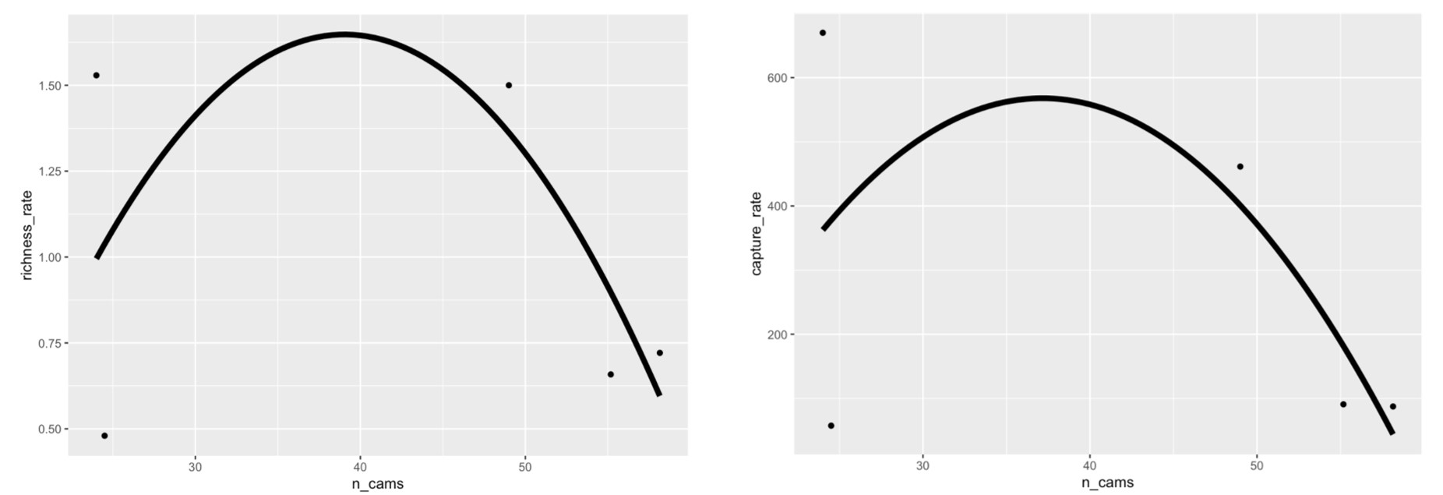**Figures and Tables**

**Figure 1. Scatter plot depicting the relation between the number of cameras (n_cams) and richness (left) and capture (right) rate. Smoothed conditional means are fitted to a linear model.**

**Table 1. Mixed Effect Model estimates and standard error (SE) are given for each ecosystem based on model for camera trap as sampling effort and the number of captures. Significant p-Values are bolded.**

|  |  |  |  |  |  |  |
| --- | --- | --- | --- | --- | --- | --- |
| **Ecosystem** | **Estimate** | **SE (±)** | **t-Value** | **ci.lb** | **ci.ub** | **p-Value** |
| **Coniferous** | 57.50 | 158.63 | 0.36 | -261.61 | 376.62 | 0.719 |
| **Deciduous** | 88.70 | 53.51 | 1.63 | -20.96 | 198.35 | 0.110 |
| **Desert** | 431.36 | 165.4 | 2.61 | 99.34 | 763.37 | **0.012** |
| **Grassland** | 525.22 | 120.85 | 4.35 | 282.10 | 786.34 | **<0.0001** |
| **Mixed Forest** | 297.10 | 226.91 | 1.31 | -159.39 | 753.58 | 0.197 |
| **Tropical** | 81.69 | 43.39 | 1.88 | -5.56 | 168.98 | 0.066 |

**Table 2. Mixed Effect Model estimates and standard error (SE) are given for each ecosystem based on model for camera trap as sampling effort and species diversity. Significant p-Values are bolded.**

|  |  |  |  |  |  |  |
| --- | --- | --- | --- | --- | --- | --- |
| **Ecosystem** | **Estimate** | **SE (±)** | **t-Value** | **ci.lb** | **ci.ub** | **p-Value** |
| **Coniferous** | 0.48 | 0.45 | 1.07 | -0.42 | 1.38 | 0.2913 |
| **Deciduous** | 0.65 | 0.16 | 4.18 | 0.34 | 0.96 | **0.0001** |
| **Desert** | 1.41 | 0.47 | 3.00 | 0.46 | 2.35 | **0.0043** |
| **Grassland** | 1.36 | 0.34 | 4.02 | 0.68 | 2.03 | **0.0002** |
| **Mixed Forest** | 3.80 | 0.77 | 4.93 | 2.25 | 5.34 | **<0.0001** |
| **Tropical** | 0.66 | 0.12 | 5.37 | 0.41 | 0.91 | **<0.0001** |

**Supplementary Appendix**

Papers obtained through database searching (Web of Science) Keywords:

Camera* Trap* AND Richness*, Diversity*, and Rarefaction* Curve*

(n= 515)

(n = 1090)

## Identification

Papers obtained from other sources, such as book chapter bibliographies

(n= 0)

## Eligibility

Records after duplicates removed   
(n = 397)

Records excluded for: relevance, review, opinion or idea paper, focus on one spices, qualitative, not English.

Records screened by abstract (n = 397)

## Screening

Full-text articles assessed for eligibility (n = 252)

(n = )

Full-text articles excluded:

Not reporting richness or diversity, number of records, and any measure of duration.

Include in synthesis

(n = 119)

## Included

Extracted data:

Location (latitude, longitude), camera trap days, number of records, animal richness, common name, scientific name, year, number of cameras, presence of bait, number of cameras, number of sites, and ecosystem.

**A. PRISMA diagram used for camera trapping effort systematic review (Moher et al. 2009). Search done with keywords: Camera* Trap* AND Richness*, Diversity*, and Rarefaction* Curve* in 2019.**

**B. Forest plots showing effect sizes for richness rate (left) and capture rate (right) in different ecosystems of study. 5 categories of ecosystems were simplified from system. Means with 95% confidence intervals are plotted. Values that have longer hortizonal lines indicate more spread in the studies. Values that are closer to the vertical dashed line are less different from the null effect.**

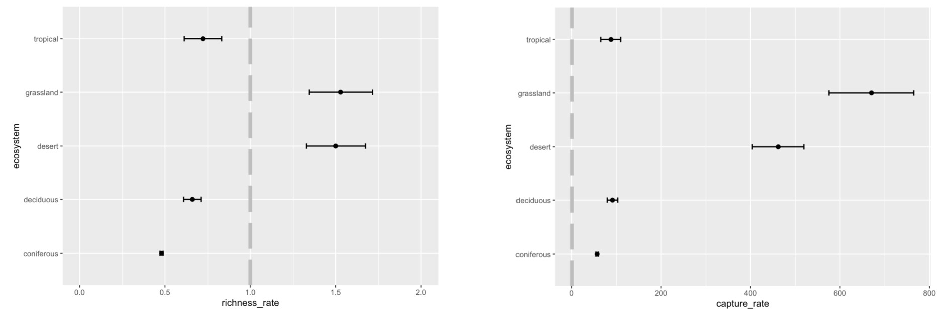

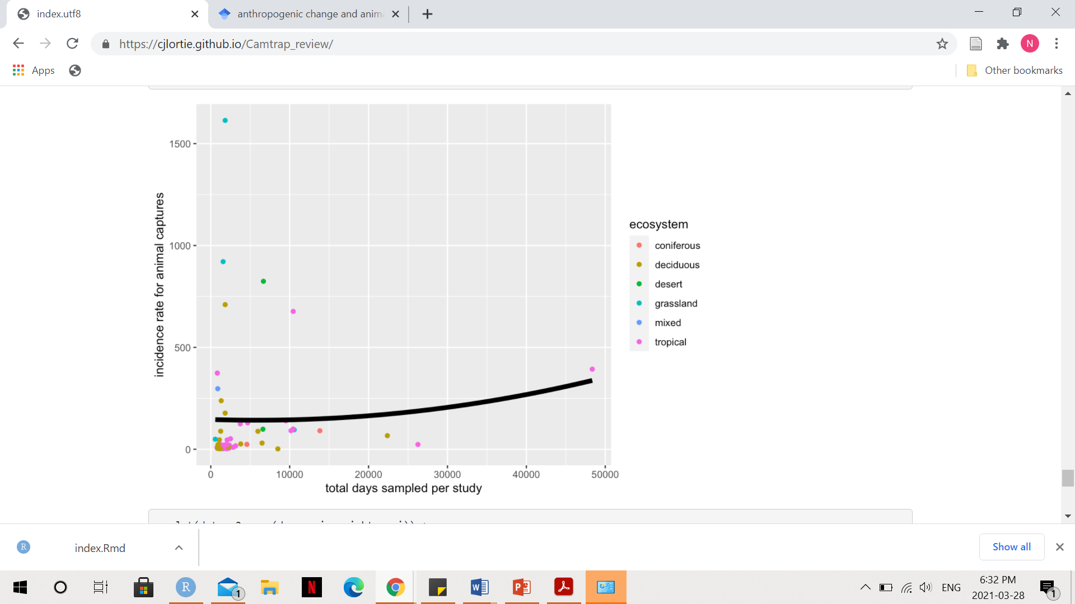

**C. Scatterplot showing the relationship between the number of camera trap study days and incidence rate for animal captures. Smoothed conditional mean is fitted using the linear model. Coloured dots represent different ecosystems.**

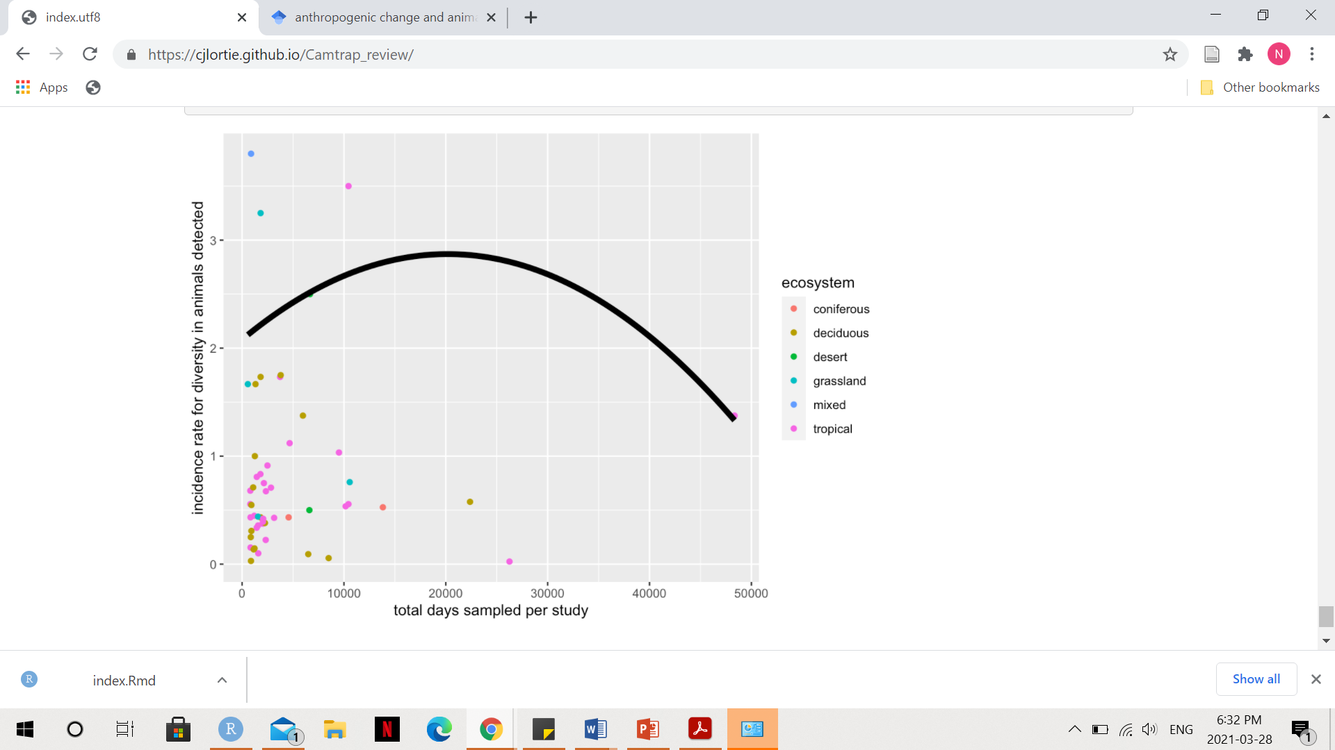

**D. Scatterplot showing the relationship between the number of camera trap study days and incidence rate diversity of animals detected. Smoothed conditional mean is fitted using the linear model. Coloured dots represent different ecosystems.**